**3388B Engineering Notes**

**VEX In The Zone 2017-2018**

**BY**

**Steven (Ji Yuan) Feng, Junyoung Seok**

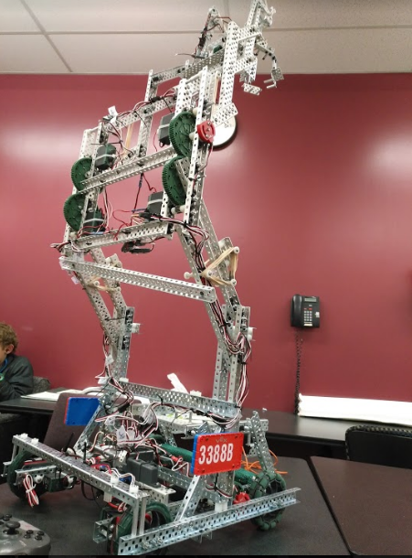

**3388B Engineering Notes VEX In The Zone 2017-2018**

**History**

Team 3388B was formed last year for the VEX Robotics Competition Starstruck, consisting Junyoung Seok, Steven Feng, and Ayush Ghosh. Last year, we ranked third in Calgary Regionals, second for skills challenge, third place in qualifications in the provincials.

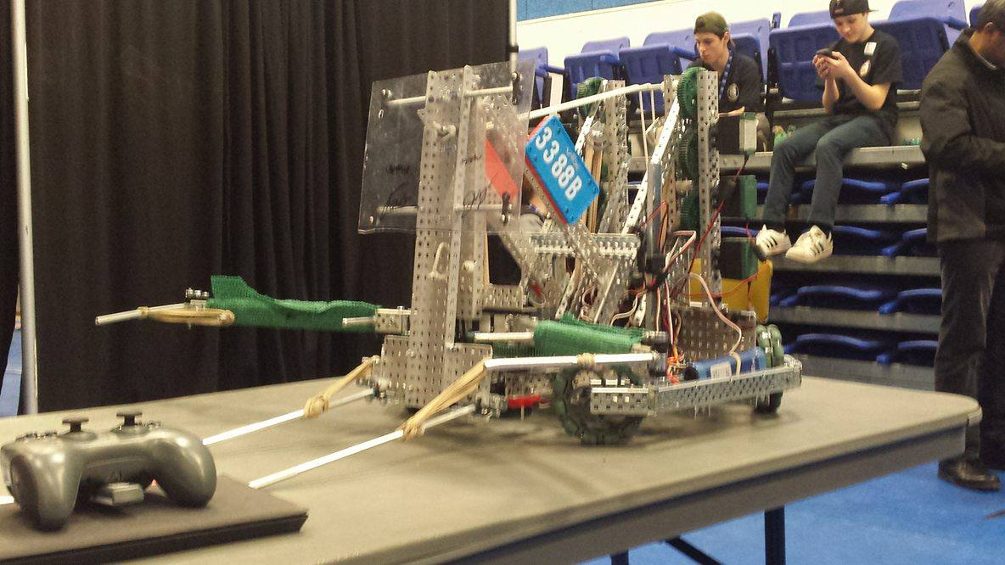

Fig. 1 Provincial championship design

**Design**

This year, we looked at several designs from various groups, and made different prototypes to determine the most efficient method to stack the most cones. Here are some of the designs that we have looked at, and some pros and cons for each of them.

**Design 1, Based on 1970K**

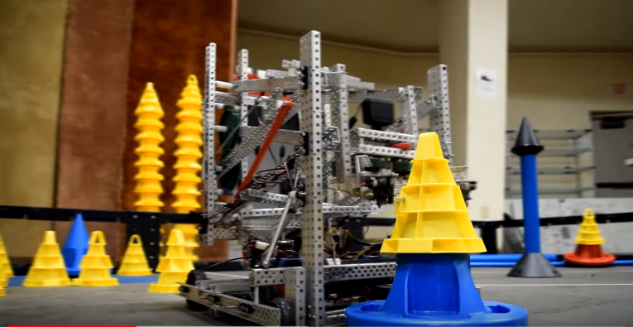

|  |  |
| --- | --- |
| Pros | Cons |
| * RD4B lift which allows it to stack very high * Very Stable * Efficient claw design * Fast moving robot | * Unable to move the mobile goals, which makes it very dependent on the alliance team * It has to move the cone to the mobile goal, which makes it very inefficient. |

**Design 2 (Based on 8059Z)**

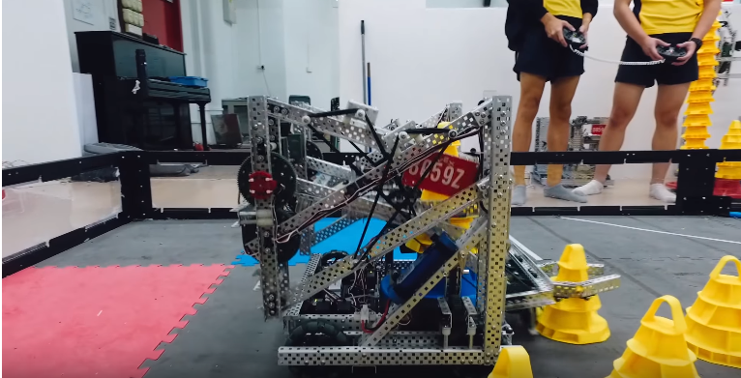

|  |  |
| --- | --- |
| Pros | Cons |
| * RD4B lift which allows it to stack very high * Stable | * Mobile Goal Intake system still lacks work. (it moves the mobile goal up, instead of transporting it) * The third stage of the RD4B lift moves downward, which makes it relatively inefficient. |

**Design 3 (Based on 8059A)**

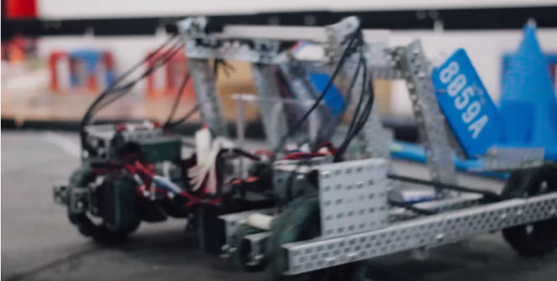

|  |  |
| --- | --- |
| Pros | Cons |
| * Small, fast and agile robot. * Easy to build and test * Very efficient mobile goal intake system, however it is slightly too big | * Unable to stack any cones. * Due to the size of the mobile goal intake, this robot has little potential to add on additional features. |

**Design 4**

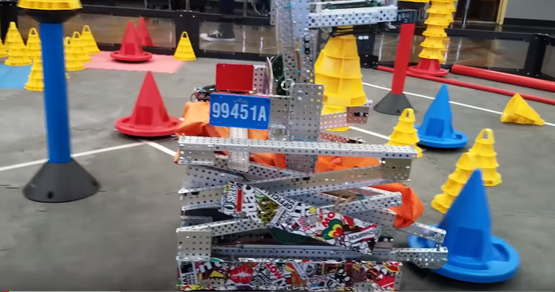

|  |  |
| --- | --- |
| Pros | Cons |
| * A mature design that can accomplish all the objectives of this game * Effective mobile goal intake system. Similar to 8059A’s but miniaturized. * Roller intake is very unique | * Scissor lift system is inefficient |

**Design 5**

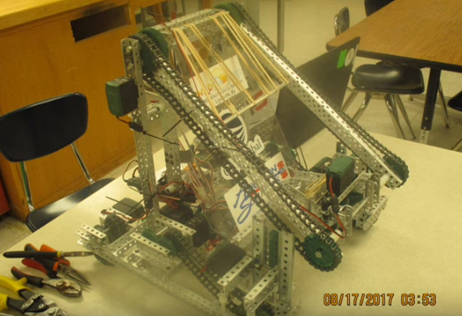

|  |  |
| --- | --- |
| Pros | Cons |
| * Small, efficient and compact design * Able to accomplish all the objectives in the game * Sufficient for the current games | * Only able to stack 6-8 cones, which makes it very limited * May not be able to do as well in the provincial championship |

**Design 6**

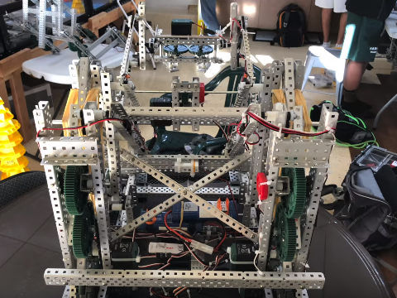

|  |  |
| --- | --- |
| Pros | Cons |
| * Efficient mobile goal intake * Good RD4B lift * Able to stack 15 cones. | * Claw is weak * Cannot turn when the RD4B lift is expanded. |

**Conclusion**

After looking at all the above designs, we came up with a series of guidelines for our robot to make it more efficient:

1. 4 motor chassis with Omni wheels in front for good turning performance while having traction
2. RD4B lift is used to stack more than 12 cones
3. Solid claw design. (consider roller intake or pneumatic claw for future improvements)
4. Parallel mobile goal intake (similar to 8059A’s but smaller and more efficient)
5. Anti tip system (future improvements)

And this is what we came up with:

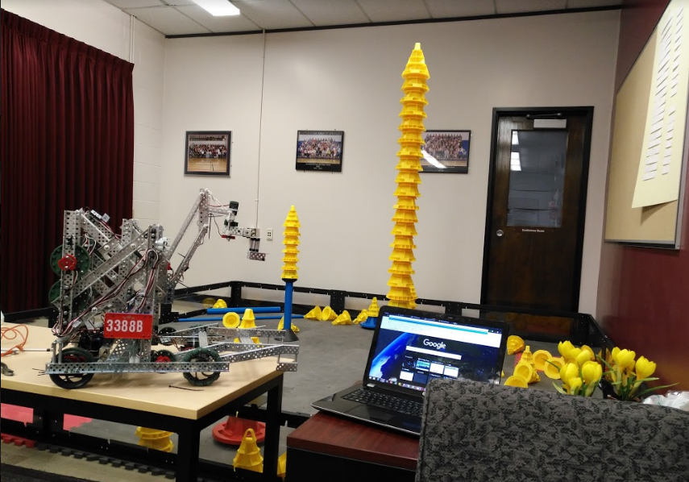

Prototype 1

Challenges:

1. Since PID failed for the claw and claw lift system, that the elastic force must be accurately manipulated to get the effect of PID
2. All parts must be planned ahead in order to fit within the limited volume
3. Wiring is long and tedious. There could be many potential errors
4. The robot is composed of hundreds of screws, which makes maintenance very challenging.
5. The claw could still be improved (even though this is the sixth prototype for the claw)

**Codes**

**Autonomous**:

We have three auton plans, however, two of which are more challenging to code, thus we are considering to do them for provincials

**Plan 1**

Robot move forward, place the pre load cone onto the mobile goal, and move the mobile goal to the 20 point zone.

Expect to get 22 to 27 points

Required Sensors: potentiometers, encoders, touch sensors, and light sensors

**Plan 2**

Robot moves forward, and score the preload cone to the stationary goal. (it is only used when the alliance has a similar code to plan 1)

Expect to get 7 points.

Required Sensors: potentiometers, encoders

**Plan 3**

Robot moves forward, place the preload cone to the mobile goal, pick up the mobile goal and move to the loader position. Load the driver load cones onto the mobile goal. (it is only used when the alliance has a similar code to plan 1)

Expect to get 10 points.

Required Sensors: potentiometers, encoders, touch sensors,

We chose plan 1 because it gives the most points and we are expecting most other teams to not have a autonomous.

Auto straightening and PID with combination of multiple sensor inputs are used to ensure the robot is consistent.

**Future Improvements:**

Gyro may be used to make sure the robot movement is consistent in the future.

**Driver Control:**

**Drive:**

Standard joystick drive to allow minor movement corrections

**Lift / Mobile Goal:**

Buttons are used to set a speed for the motors to prevent it from burning out

**Third stage lift and Claw**

5 UD and 6 UD are used for ease of access

**Future improvements:**

A two driver system may be implemented to reduce the difficulty of driving

Difficulties:

1. Enabling PID on the claw and third stage lift
2. Accurately predict turn angles in autonomous using encoders only
3. Some sensors do not function fully.